INSC 568
Final Project – Enterprise Integration
Ky Ferguson
Contents
Project Description 2
Student Roster Information System Stack 3
Course Registration Information System Stack 3
Integration Approach 4
APIs 6
Get the list of selected courses & Retrieve relevant course information from Course System 7
Update Course and Roster systems with students selected course information 8
Testing 9

Project Description
Lion University has two applications, Student Roster Information System (Roster System) and Course Registration Information System (Course System). They are standalone applications, developed in-house. To ensure that students can register their courses without hassle, Lion University decided to implement a process-level integration to manage the course registration process from end to end. When a student clicks “Registration” a process will be initiated that manages solely their registration until the process is finished.

Four remote invocations are necessary:
- Get the list of selected courses from Course System
- Retrieve relevant course information from Course System
- Update Course System with students selected course information
- Update Roster System with selected course information

The student will take these actions:
- Choose a course from list defined by configurations for each Major, and availability in the Term.
- Upon choosing a course, they may need to await approval from their advisor
- Upon choosing a course, there will sometimes be additional consultation with the course Instructor
- Submit the courses

Student Roster Information System Stack
- Java Program
- Oracle Database
- Client/Server Architecture
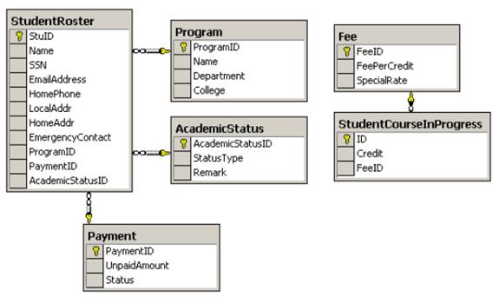

Course Registration Information System Stack
- C# Program
- MS SQL Database
- .Net Web-based Architecture

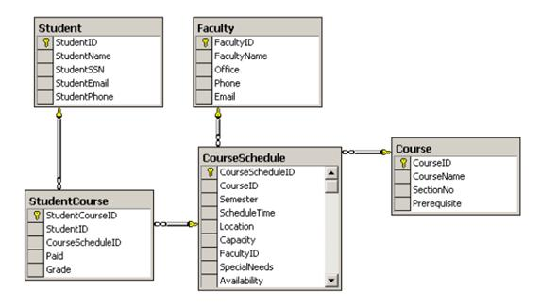

Integration Approach
I set up basic json arrays of objects instead of creating a real database. I based the json files on the relationship diagram in the final project instructions with small quality of life improvements.
Each “table” of data is stored within an array of objects in a json file. I created four academic statuses.
- Applicant
- Admitted
- Enrolled
- Probation
Because “graduates” don’t typically enroll in courses without first applying for another program, I didn’t mock any data related to a ‘graduated’ enrollment status. I created three programs and added courses to each. I only created courses for the upcoming term, F2026.
Because I’m using self-signed certifications and requiring HTTPs, I had to configure insomnia to ignore certificate validation to use the APIs.

Student Roster | {  "students": [  {  "stuId": "STU001",  "name": "William Nylander",  "SSN": "",  "emailAddress": "williamNylander@psu.edu",  "homePhone": "",  "localAddr": "",  "homeAddr": "",  "emergencyContact": "",  "programID": "INSC",  "paymentID": "",  "academicStatusID": "1",  "createdAt": "2026-04-17T10:00:00Z",  "updatedAt": "2026-04-20T00:05:00Z"  }  ]  }
Student Academic Status | {  "academicStatuses": [  {  "academicStatusID": "1",  "statusType": "admitted",  "remark": "",  "createdAt": "2026-04-17T10:00:00Z",  "updatedAt": "2026-04-17T10:00:00Z"  }  ]  }
Courses | {  "courseSchedules": [  {  "courseScheduleID": "INSC 568 F2026",  "courseID": "INSC 568",  "semester": "F2026",  "scheduleTime": "10:00 AM",  "location": "Room 101",  "capacity": 30,  "enrolledCount": 0,  "facultyID": "123456789",  "specialNeeds": "N/A",  "availability": true,  "createdAt": "2026-04-17T10:00:00Z",  "updatedAt": "2026-04-20T00:05:00Z"  }  ]  }
Programs | {  "programs": [  {  "programID": "INSC",  "name": "Information Systems",  "department": "Engineering",  "college": "Engineering",  "createdAt": "2026-04-17T10:00:00Z",  "updatedAt": "2026-04-17T10:00:00Z"  }  ]  }
Student Courses Requested | {  "enrollments": [  {  "enrollmentId": "ENR001",  "studentId": "STU001",  "courseScheduleId": "INSC 580 F2026",  "credit": 3,  "feeID": "FEE001",  "createdAt": "2026-04-20T00:13:32.397Z",  "updatedAt": "2026-04-20T00:13:32.397Z"  }  ]  }

APIs
To cover the four remote invocations called out in the assignment description, I built a total of six APIs, with a seventh for troubleshooting my local environment set up.

Get the list of selected courses & Retrieve relevant course information from Course System
To progress the (front-end system) student user to the point where they can retrieve a list of courses they’re eligible to enroll in, they first need to apply and be admitted to a program.
The ‘create student’ API /api/public/students allows a web or mobile application to create a record for a newly applying student. Once the form is submitted, the server creates the record and sets their academic status to “applicant”.
Then it parses and validates the request, including checking for duplicates based on email address. In a real university setting, additional de-duplication logic would be needed for fields like SSN. Next it looks up the program ID and generates a student ID, then creates records in the studentRoster and academicStatuses databases. The service abstracts errors away from the API responses to avoid exposing information like the SSN to the client.
Then, so I could avoid manually editing fields in the database files, I created a simple POST endpoint that could be consumed by an admissions client system. Upon successful review of the program application, the admissions agent can submit a request to /api/students/admit, updating their status to “admitted”, allowing them to register for courses.
Finally, the student’s front-end registration system can retrieve their enrollment information using /api/enrollment-info?studentId={id}. In an enterprise organization, this lookup would be tied to an account identity. In this case, the API lookup is done based on the student ID or email address. Then the program and academic status tables are joined to provide the students enrollment status. Registration eligibility is provided to the front-end client in the isRegistrationEligible field. Only students with statusType “admitted" or "enrolled" get canRegister = true. An "applicant" who hasn't been admitted yet gets canRegister: false. The front-end system can use these values to surface screens informing the student to wait patiently for their acceptance or rejection. If the user can register, the API also returns which courses the student’s program has available. The server filters the available courses by availability of “open” and programId that matches the student’s enrolled program.
The course object also informs the front-end whether they should inform the student that the course registration is automatic or will need reviewed by an advisor using the boolean requiresAdvisorApproval field. The courseDescriptionUrl is computed on-the-fly by getEnrollmentInfo using a base URL and the course ID.
We can imagine a front-end client presenting the data they’ve requested like the webpage mock shown below. This is a screenshot of AI-generated HTML that was fed the course registration API response data structure as a prompt with the requested output being a non-functional HTML mock.
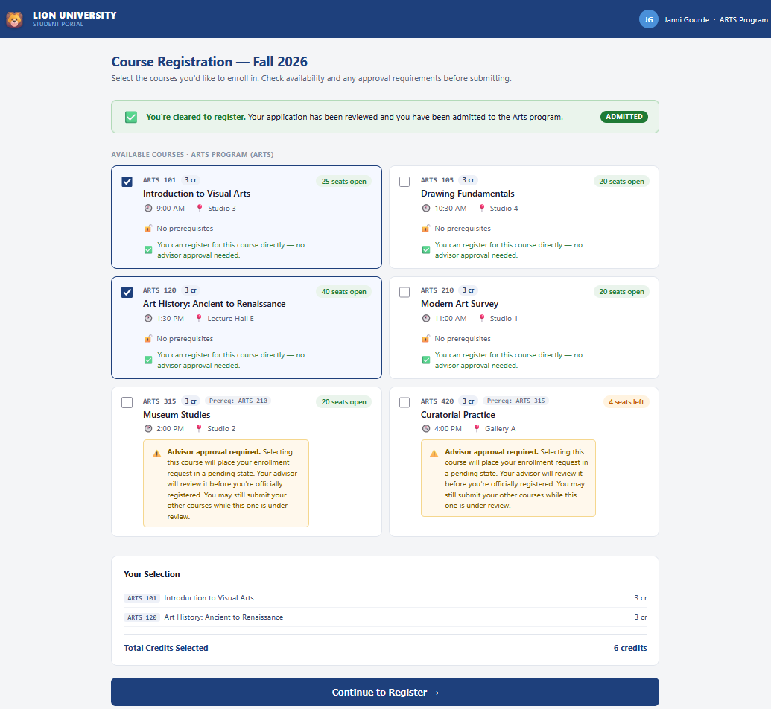

Update Course and Roster systems with students selected course information
When the user makes their selections, the next call is a POST to request to the registration endpoint, /api/enrollments. The request body includes the student ID and the course-schedule IDs from the information API. This service verifies the student’s enrollment status, and validates that the courses they’ve selected belong to their program. Then the system validates the requested courses capacity. If any of these rule checks fail, in addition to de-duplication logic, the request is rejected with a front-end friendly error.
In one transaction, the service updates the Roster system in the student_course_inprogress table and the Course Registration system’s course_schedule table. student_course_inprogress handles connecting the individual student to their personal registration. The course_schedule table shows each available course including their enrolled count. If both records can’t be updated, each is reverted to a snapshot and the API fails.
When an enrollment request requires approval from an advisor, a message is placed on a messaging queue to simulate informing an external staff-facing system and external users of a necessary action.

Integration documentation is provided in the openapi.yaml file. The web application used for course registration would use this as specifications to integrate with the roster server.
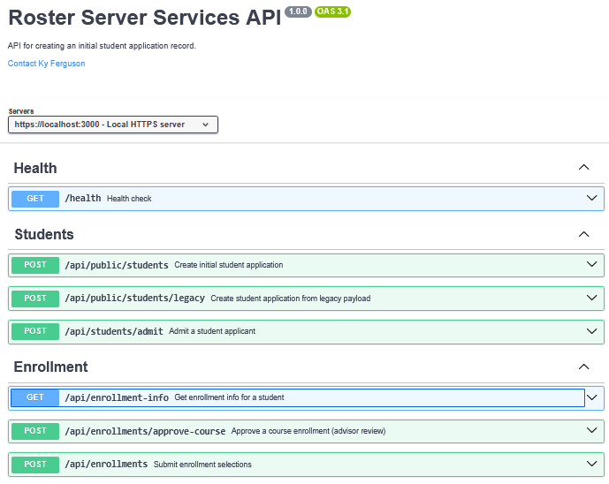

Testing
To make testing easy, I imported the openapi.yaml API specification file into Insomia so I could make calls simulating a front-end client.
First, I reused APIs created from Hands-On Project 6 for creating students.
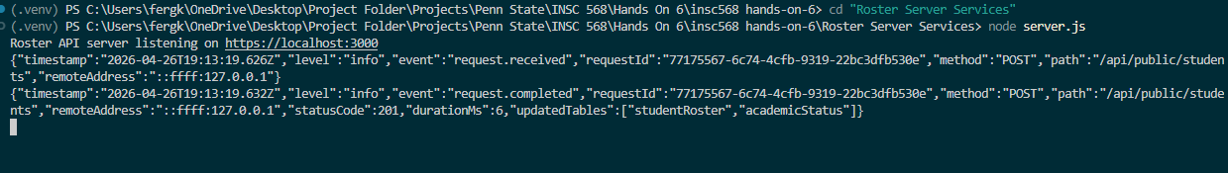
I created a new test student in the ARTS program.
Then I used a newly created POST API to admit the student. This API is intended to be used by an external admissions team.
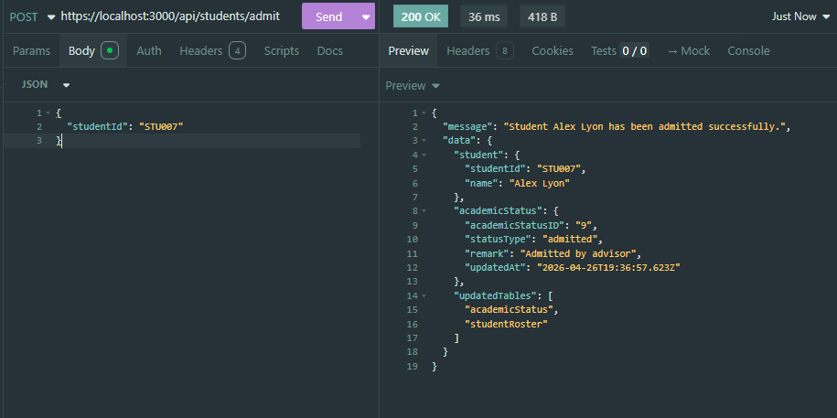
I reused the GET Enrollment Info from Hands-On Project 6. Before admitting the student, the student’s statusType was “applicant” which doesn’t allow them to enroll in courses.
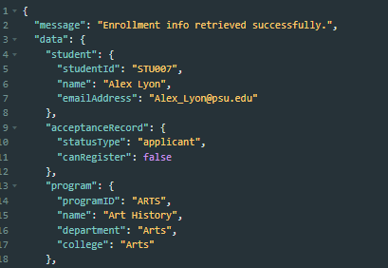
After admitting the student, their status in Get Enrollment Info is updated.
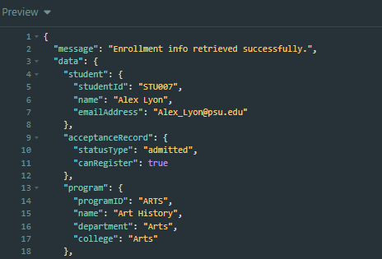
The user can use the registration client to browse the available courses.
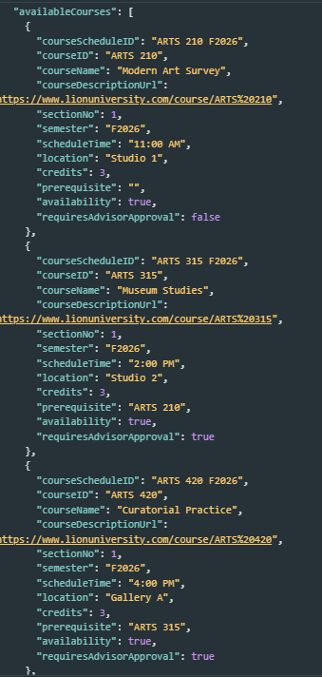
Then pass those values into the enrollment API
